CMP6200/DIG6200
Individual Undergraduate Project (FYP)
Final Report
[Reinforcement Learning to improve AI behaviour and adaptability in a game environment]

Student Name: Tamer Hussen
Student ID: S23130437
Course: Computer Games Technology
Supervisor: Jan Krasniewicz
Date: 5/5/26

Abstract
The project investigates the use of reinforcement learning (RL) to produce adaptive, believable non player characters (NPCs) within a unity game environment. Using unity ML-Agents, the work involves designing controlled training environments, implementing RL agents using proximal policy optimization (PPO), and comparing their behaviour against a custom C# scripted behaviour tree baseline utilising A* NavMesh pathfinding. The artefact is a Predator and Prey arena featuring an AI agent equipped with complex sensory systems, including a vision cone, hearing, and a multipoint scent trail. Training evaluations, capped at 20 million steps, revealed that while early-stage learning produces coherent tracking behaviours, extended training can exhibit instability and low reward plateaus. By introducing distraction animals, dynamic prey evasion tactics and a strategic familiar summoning system, the model successfully comes together. Outcomes demonstrate the critical importance of sensory integrity and reward shaping in practical RL, showing the trade-offs between designer control, and developing adaptability in playable game development.
Contents
Abstract 2
1.0 Introduction and Problem Statement 5
1.1 Introduction and Context 5
1.2 Problem Statement 5
2.0 Literature Review 5
2.1 Review of Existing Knowledge 5
2.2 Critical Analysis and Gap Identification 6
2.3 Project Justification 6
3.0 Project Aims, Objectives, and Scope 7
3.1 Project Aim 7
3.2 Project Objectives 7
3.3 Project Scope 8
4. System Design and Architecture 8
4.1 Design and Methods 8
4.2 Justification of Methods 10
4.3 Environment Architecture and Player Systems 11
4.4 AI Sensory Systems Implementation 14
4.5 Reinforcement Learning Setup (ML-Agent & PPO) 15
5. Implementation (Unity, ML Agents, YAML) 15
5.1 The Behaviour Tree Baseline 15
5.2 Construction of the Artefact 16
5.3 Model Export and Inference 16
6. Experimental Method 17
6.1 Validation and Testing 17
7. Results 17
8. Comparative Analysis 19
8.1 Critical Evaluation 19
9. Discussion 20
9.1 Limitations 20
9.2 Impact 21
10. Conclusion and Future Work 21
10.1 Conclusion 21
10.2 Future Work 21
References 22
List of Assets used in implementation 23
Appendices 24

Figure 1: GitHub Kanban board shows the transition from technical development phase to the final evaluation and reporting phase 10
Figure 2: Previous Gantt Chart 10
Figure 3: New Gantt Chart 10
Figure 4: Game Variables 12
Figure 5: Top-Down view of Arena 13
Figure 6: First person view 13
Figure 7: Training scene 14
Figure 8: Mean Reward progression across the 20 million step curriculum 18
Figure 9: Player Enemy Preference 19
Figure 10: Perceived Realism Comparison 20
Figure 11: YAML 25
Figure 12: ML Agent - Observation and Reward System 26
Figure 13: BT Agent – BT Structure and Nodes 27

Table 1: Technical Performance 18
Table 2: Tester Results 18
Table 3 : Risk Assessment 28

1.0 Introduction and Problem Statement

1.1 Introduction and Context
The project investigates how Reinforcement Learning (RL) can make artificial intelligence (AI) agents more adaptive and capable in a video game context. Reinforcement Learning is a branch of machine learning in which systems learn from experience, rewarding them for advantageous behaviours and punishing them for disadvantageous behaviours, rather than relying on prescribed rules (Sutton & Barto, 2018) (MLVU, 2022). In modern game development, most AI or NPC systems use scripted or rule-based logic, which can lead to the AI agent becoming more predictable once the player observes the patterns built into the system (Tang, 2023). By using RL, an AI agent can learn and improve while interacting with an environment, which can improve engagement and increase replayability (Mnih, et al., 2015) (Silver, et al., 2017).
The project uses Unity’s ML-Agents toolkit to implement machine learning based AI. ML-Agents enables reinforcement learning directly within Unity using C#, allowing agents to interact with the game environment, receive feedback and adapt their behaviour through repeated simulations (Juliani, et al., 2018). This makes it possible to visualise and assess learning outcomes in real time, providing a practical way to develop and evaluate AI behaviour. The main goal of the project is to link RL focused academic research and practical applications of game AI, exploring whether RL can be used effectively to improve AI behaviour in playable games (Senanayake, 2025).

1.2 Problem Statement
Normally, AI systems for games are fixed and predictable, basing their behaviours upon pre-defined scripts or decision trees that are unable to learn and adapt to the changing behaviour of the player (Glavin & Madden, 2018). This lack of adaptable AI limits player engagement and replayability. To address this issue, the research examines how Reinforcement Learning can promote a more adaptive, self-learning AI that alters its behaviour through environmental feedback within Unity, ultimately comparing its efficiency and believability against a traditional Behaviour Tree baseline (Lample & Chaplot, 2017) (Isbister & Nass, 2000).

2.0 Literature Review

2.1 Review of Existing Knowledge
The combination of artificial intelligence in video games has historically relied on pre-scripted, deterministic models. Traditional game AI techniques such as Finite State Machines(FSMs) and Behaviour Trees(BT) are widely considered simple and effective solutions for generating non-player character(NPC) logic. Behaviour Trees, in particular, provide an organised, hierarchical structure of sequences, selectors, and conditions that dictate exact optimal pathing – often utilising algorithms like A* via NavMesh for flawless navigation (Khan, 2014). However, while these standard algorithms are highly efficient, they lack true adaptability. They execute precisely what is programmed, which can result in predictable and rigid gameplay once players learn the underlying patterns (Tang, 2023).
In contrast, Reinforcement Learning(RL) enables continuous learning and adaptive behaviour. RL is based on the interaction between three main components: the agent, the environment, and the reward system (Datatonic, 2022). Over time, through algorithms like Proximal Policy Optimisation(PPO), a stable, sample efficient method commonly used in continuous control tasks , the agent learns to maximise positive benefits through trial and error (Schulman, et al., 2017). Frameworks such as Unity’s ML-Agents toolkit have recently made it possible to integrate these complex machine learning models directly within game environments (Juliani, et al., 2018), allowing developers to implement simulated training sessions where agents continuously improve navigation, pathfinding, and decision making over repeated trails.

2.2 Critical Analysis and Gap Identification
Although Reinforcement Learning theory is studied and reviewed to a large extent (Pan & Yang, 2010), a critical gap remains in its practical applications within the gaming industry. Previous research has shown significant potential for RL in applied fields like robotics and autonomous vehicles, but research into its applications in interactive video games is minimal. Most RL studies focus on controlled, non-playable simulation optimised purely for task completion (Mnih, et al., 2015), without analysing if learning positively impacts in game adaptability, believability, or player engagement.
Furthermore, there is a distinct lack of comparative evaluations between RL-driven agents and traditional, highly optimised AI architectures. While traditional Behaviour Trees use perfect mathematical pathfinding, ML agents must learn to steer via trial and error (Hester, et al., 2018), creating a potential for evolving behaviours, such as cutting off a player’s path or flanking, that are not explicitly programmed (Jaderberg, et al., 2019). Currently, there is insufficient research evaluating the practical trade-offs between the rigid predictability of Behaviour Trees and the developing adaptability of PPO agents when placed in identical, playable scenarios.

2.3 Project Justification
This project addresses the identified gap by building a playable, Unity-based predator and prey environment designed to display and evaluate reinforcement learning in a realistic gaming setting (Senanayake, 2025). By developing two identical AI predator agents , one controlled by a significantly trained PPO ML- Agent and the other by a custom built, NavMesh driven Behaviour Tree, this project establishes a rigorous baseline for scientific comparison.
The project will investigate how altering aspects of reward system, environmental complexity ( such as distraction animals), and sensory integrity (vision, hearing, and scent trails) affects the ML agent’s learning speed and hunting behaviour (Bontrager, et al., 2018) (Zook, et al., 2019). Comparing the PPO trained agent against a traditional scripted AI will highlight the dynamic difference in learning, developing tactics and adaptability (Glavin & Madden, 2018). Ultimately, the outcome of this comparative analysis will contribute to a better understanding of how RL can be practically used in real time game development, proving whether learned hunting styles are more effective and engaging than standard, optimal pathing AI (Lample & Chaplot, 2017).

3.0 Project Aims, Objectives, and Scope

3.1 Project Aim
The aim of this project is to design, create and assess a reinforcement learning system within a Unity based ‘Predator and Prey’ game environment to evaluate whether an AI’s adaptability, developing behaviour, and decision-making processes offer a more engaging and effective alternative to traditional scripted AI baselines (Senanayake, 2025).

3.2 Project Objectives
- Objective 1: Create a 3D ‘ Predator and Prey’ Unity environment equipped with complex AI sensory systems, including a vision cone, hearing via a sound emitter system, and a multipoint scent trail (Khan, 2014).
- Objective 2: Implement and train a Proximal Policy Optimisation (PPO) agent using Unity’s ML-Agents toolkit (Juliani, et al., 2018), using targeted reward shaping and multi-phase curriculum training up to 20 million steps (Schulman, et al., 2017).
- Objective 3: Continuously improve the reward structure and environment design, such as introducing distraction animals and a familiar summoning system, to break low reward training periods and prevent aiming for the minimum (Bontrager, et al., 2018).
- Objective 4: Develop a custom , A* NavMesh driven Behaviour Tree(BT) baseline from scratch, mirroring the ML agent’s speeds, recognition thresholds, and cooldowns to ensure a scientifically fair comparison (Glavin & Madden, 2018).
- Objective 5: Evaluate and compare the performance, learning rates, and developing behaviour of the RL agent against the rigid pathfinding of the scripted BT baseline within identical playable survival scenarios (Lample & Chaplot, 2017).
- Objective 6: Conduct an analysis of agent believability and tactical development, assessing whether the RL agent exhibits human like strategies such as flanking or ambushes (Isbister & Nass, 2000) (Jaderberg, et al., 2019).

3.3 Project Scope
To ensure the project remained focused and achievable within the given time limit, clear boundaries were established.
Included:
- Integration of the Unity ML-Agent toolkit to facilitate reinforcement learning directly within the engine (Juliani, et al., 2018).
- Development of a specialised Predator and Prey simulated environment.
- Implementation of advanced sensory mechanics, such as sight, sound and scent masking, and environmental distractions, like wandering animals (Zook, et al., 2019).
- Creation of a custom C# Behaviour Tree for direct comparison.
- Visualisation of training progress via generated data logs, debug UIs, and ONNX model exports (Datatonic, 2022).
Excluded:
- The ‘Adaptive Maze Runner’ sub goal, which was removed from the scope early in development to ensure the core Predator and Prey arena reached stability and complexity.
- Multiplayer or online networked systems.
- Physical robotics or real- world machine learning applications.
- Deep learning architectures require high end computing power outside of the standard ML-Agent framework.

4. System Design and Architecture

4.1 Design and Methods
The project used an iterative, Agile inspired software development methodology, prioritising rapid prototyping, continuous testing, and sequential complexity scaling. The core artefact was developed using the unity engine (C#), supported by the Unity ML-Agents toolkit to facilitate the machine learning environment (Juliani, et al., 2018).
The design is split into three primary methodological phases:
- System architecture and Environment Design:
  - A 3D ‘Predator and prey’ survival arena was constructed featuring dynamic terrain, solid obstacles (like walls, trees, and rocks) and soft obstacles (bushes to mask scent and block line of sight).
  - The AI agents were equipped with complex multi layered sensory inputs: a multi ray vision cone, a volume-based hearing system capable of distinguishing sound sources and a timed multipoint scent trail.
- Algorithm implementation and training regime:
  - The ML agent: A Proximal Policy Optimisation (PPO) algorithm was selected to drive the learning predator (Schulman, et al., 2017). The agent’s neural network was configured using YAML files, feeding a 90-dimension observation vector into the model (Datatonic, 2022). Training was conducted over a rigorous 20 million step curriculum divided into sequential phases:
    - Establishing basic tracking – phase 1
    - Introducing aerial and ground familiars - phase 2
    - Adding distraction animals to evaluate sensory filtering – phase 3
    - Fine tuning speed/ stamina mechanics to break reward plateaus – phase 4 and 5.
  - The Baseline Agent: To establish a control group, a custom Behaviour Tree (BT) framework was architected entirely from scratch in C#. The BT uses A* pathfinding via Unity’s NavMesh to navigate the arena optimally (Khan, 2014), its decision-making hierarchy evaluates eight specific states per frame (like strike, stalk, track scent, summon familiar, etc), providing a rigid, mathematically flawless counterpart to the ML agent.
- Validation and evaluation methods:
  - Evaluation relies on a side-by-side comparative methodology. Both the ML Agent and the BT baseline were contained to identical parameters, which were speeds, recognition thresholds, cooldowns, and stamina limits. Data logging and in game debug UIs were used to record quantitative metrics( for example detection distance, time to catch, success rates), and qualitative developing behaviours during playable survival scenarios.

Figure 1: GitHub Kanban board shows the transition from technical development phase to the final evaluation and reporting phase
GitHub Kanban Link
Figure 2: Previous Gantt Chart
Figure 3: New Gantt Chart
Gantt Charts Link
While the original Gant chart (figure 2) anticipated a linear progression, the updated version (figure 3) reflects a 1-month shift in the development cycle. This extension was necessary to resolve training instabilities and reward plateaus encounter between the 12 million and 15 million step marks. While the overall Gantt timeline tracks these major phases , the GitHub kanban board (figure 1) was used for daily management of fixes, such as stamina balancing and UI tweaks.

4.2 Justification of Methods
Unity’s ML Agents toolkit was selected over standalone frameworks like TensorFlow or PyTorch because it natively supports interactive 3D physics environments, allowing for the real time simulation, visualisation, and data logging of the agent’s learning process within a single workflow (Juliani, et al., 2018).
The PPO algorithm was specifically chosen for the ML agent because it is highly sample efficient and exceptionally stable for continuous control and complex navigation tasks (Schulman, et al., 2017) (Mnih, et al., 2015), which are crucial for an AI required to traverse 3D terrain while parsing diverse sensory inputs.
For the comparative baseline, a custom-built Behaviour Tree with A* NavMesh was used rather than standard Unity AI scripts. Because the BT executes optimal, mathematically calculated paths without trial and error it serves as the perfect hard coded control (Glavin & Madden, 2018). Mirroring the exact speeds and constraints across both the BT and ML agent ensuring that the final evaluation is scientifically fair. This methodology effectively isolates the variable being evaluated, which the ML agent’s learned, evolving hunting style versus the rigid predictability of a human designed algorithm, to conclusively answer the project’s core research question.

4.3 Environment Architecture and Player Systems
The simulation environment was constructed in Unity, using imported 3D assets (ALP and Nobiax/Yughues) to create a rocky, walled off survival arena. The arena features hard obstacles like walls and rocks to break the line of sight, and soft obstacles like bushes that are used to mask the players scent.
A first-person player controller was implemented to function as the prey. Based on pilot testing and iterative balancing, several player centric systems were refined to ensure fairness and atmospheric tension during evaluation:
- Audio and visual cues: A dynamic audio fade system and an expanded dark vignette effect were implemented to warn the player visually and audibly as the predator approaches, creating a sense of dread before physical contact.
- Control refinements: default mouse sensitivity was optimised, and a live UI sensitive slider was added to ensure human testers had precise control during evasion manoeuvres.

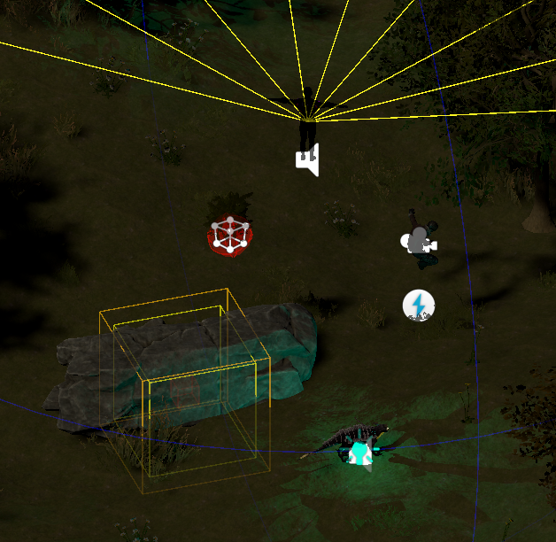
Distraction Animals
Player
Solid Obstacle
Soft Obstacle
enemy
Figure 4: Game Variables
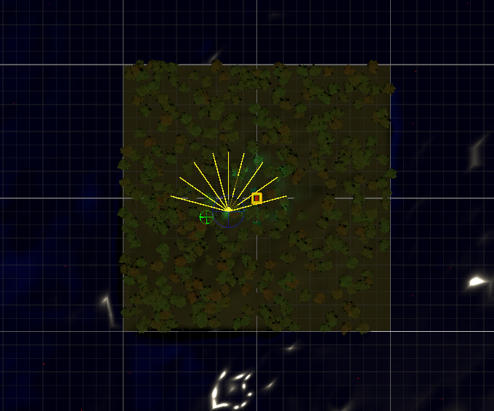
Figure 5: Top-Down view of Arena
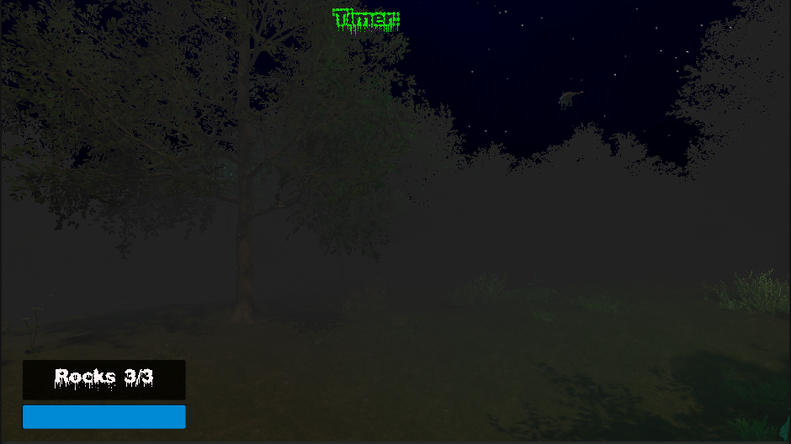
Figure 6: First person view

4.4 AI Sensory Systems Implementation
To ensure the ML agent had sufficient data to learn complex tracking rather than relying on random exploration, a 90-dimension observation vector was established (Hester, et al., 2018). This vector is fed by three primary custom built sensory mechanisms:
- Visual system: A multi ray cast vison cone detects line of sight collisions with the player dynamically updating the agent’s target tracking when the player is not obscured by solid obstacles (Khan, 2014).
- Hearing system: A volume-based audio detection mechanism allows the agent to perceive sound emitters. Crucially, this system is programmed to distinguish between the footsteps of the player and the ambient noise generated by the newly introduced distraction animals, forcing the agent to learn to filter out irrelevant audio cues (Jaderberg, et al., 2019).
- Multipoint scent trail: A time limited trail of scent markers is left behind by the player . The agent detects these nodes to track the player’s historical path. If the player enters a designated soft obstacle like a bush, the scent emission is temporarily masked, forcing the agent to rely on visual or audio search patterns.
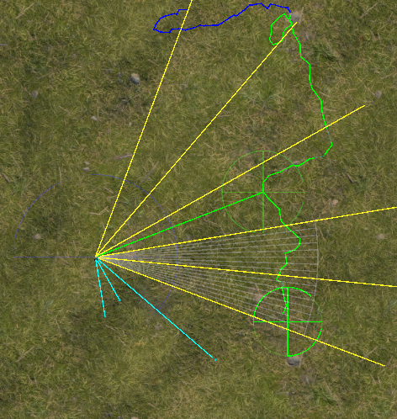
Hearing System
Visual System
Trail system
Figure 7: Training scene

4.5 Reinforcement Learning Setup (ML-Agent & PPO)
The predator’s learning was driven by the Proximal Policy Optimisation(PPO) algorithm via Unity’s ML-Agents package (Juliani, et al., 2018) (Schulman, et al., 2017). The agent’s neural network and training hyperparameters were configured using a YAML file (see Appendix A for full YAML code), carefully balancing the learning rate , batch size, and buffer size to maintain stability over extended runs (MLVU, 2022) (Datatonic, 2022).
Training was executed via the command line console over a massive 20 million step curriculum. The reward function was heavily shaped to encourage efficient hunting while penalising unreliable movements:
- Positive rewards: Granted for moving closer to the player, maintain the line of sight and successfully capturing the player.
- Negative rewards: Applied for colliding with solid obstacles, losing the scent trail, failing to capture the player within a set time limit or exploiting reward loopholes( like spinning to artificially maintain line of sight).
Once a training phase stabilised , the resulting neural network was exported as an ONNX ( open neural network exchange) checkpoint and assigned to the in-game agent for real time inference and testing.

5. Implementation (Unity, ML Agents, YAML)

5.1 The Behaviour Tree Baseline
To scientifically evaluate the ML agent’s developing behaviour, a traditional Behaviour Tree (BT) was written entirely in C# to serve as a control. The BT uses Unity’s NavMesh and A* pathfinding to generate mathematically optimal routes to the player (Khan, 2014). The hierarchy evaluates eight distinct states per frame, prioritising immediate strikes if the player is visible, falling back to scent tracking and using a summon familiar state when the player’s trail is lost.
To ensure a perfectly fair evaluation between the two agents, absolute similarity was maintained regarding physical constraints. Specifically, stamina drain for the predators was disabled entirely because the ML agent lacks the built in , flawless pathfinding of the NavMesh, disabling stamina ensured it was fairly exhausted by micro corrections during navigation, allowing the final comparative analysis to focus purely on decision making and tracking logic (Glavin & Madden, 2018).

5.2 Construction of the Artefact
The Enemy behaviour was inspired by the 1987 film Predator in which the alien was hunting the team of elite soldiers one by one. The construction of the ML predator relied heavily on a multi phased curriculum training approach (Sutton & Barto, 2018), ultimately capping at 20 million steps. Rather than placing the agent into a fully complex environment immediately, the training was sequenced to all the neural network to build foundational logic before managing sensory noise (Pan & Yang, 2010):
- Phase 1 (0 – 2 million steps): The agent was placed in a clean environment to learn fundamental navigation, wall avoidance, and scent trail following.
- Phase 2 ( 2 – 5 million steps): The agent was given the ability to summon AI familiars ( ground and aerial scouts). A penalty of -0.1 was add for summoning to prevent the agent from spamming the ability (Bontrager, et al., 2018), forcing it to use familiars strategically only when the scent trail was lost.
- Phase 3,4 and 5 ( 5 – 20 million steps): Wandering distraction animals were unhidden to evaluate the agent’s ability to filter out irrelevant audio and visual noise. Furthermore, a curiosity module was integrated into the YAML configuration, providing a natural reward for exploring the map, which successfully prevented the agent from spinning in circles (Burda, et al., 2018) when no immediate trail was found.
A significant challenge during constriction was a severe low reward training plateau where the predator caught the player too quickly, failing to learn advanced stalking tactics. This was resolved by dynamically bugging the player’s walking speed to 2.75 and sprinting speed to 5.5, allowing the player to outpace the predator in short bursts. This forced the ML agent to learn developing cut off and cornering strategies rather than relying on brute force chasing (Jaderberg, et al., 2019).

5.3 Model Export and Inference
Once the curriculum training reached the 20 million step milestone, the brain was exported from the Python environment as an ONNX file (Juliani, et al., 2018). This file contains the finalised neural network, capturing all the learned logic from the training sessions.
To integrate this into the final game, the ONNX model was assigned to the Behaviour Parameters component on the Predator prefab. Switching from default/ heuristic mode (training mode) to inference mode meant the agent could now make real time decisions directly inside the Unity engine, completely independent of the Python API. This ensured the agent could run efficiently as a standalone feature of the game without any external lag or connection requirements (Datatonic, 2022).

6. Experimental Method

6.1 Validation and Testing
To ensure that the ML agent functioned as intended and to allow for fair comparative testing, the following frameworks and gameplay mechanics were established:
- Side-by-side debugging: A custom Debug UI was built to run both the ML agent and the Behaviour Tree agent simultaneously on screen. This UI displayed the agents’ internal states, cumulative rewards, Line of Sight (LOS) status, and distance to the player, allowing for real-time monitoring of their decision-making processes (Juliani, et al., 2018) (Datatonic, 2022).
- Player testing infrastructure: A main menu was developed, allowing human testers to choose to survive against either the ML predator or the BT predator (Isbister & Nass, 2000).
- Objective Evaluation Metrics: To move beyond purely subjective player feedback, a strict timed escape win condition was added. Survival for 90 seconds triggers an escape zone, providing data on success states, time to catch, and detection distance for the final comparison (Lample & Chaplot, 2017) (Glavin & Madden, 2018).
- Iterative bug resolution: Validation testing revealed critical physics and logic bugs, such as the ML agent jittering due to conflicting Update and FixedUpdate animation triggers, and map randomisers spawning obstacles inside walls. These issues were systematically resolved to ensure smooth uninterrupted gameplay during evaluations (Bontrager, et al., 2018) (Zook, et al., 2019).

7. Results
Testing successfully confirms the artefact functions as a playable ‘Predator and Prey’ survival arena, integrating a complex reinforcement learning (RL) agent capable of navigating 3D terrain and parsing multi layered sensory inputs (sight, sound, and scent) (Juliani, et al., 2018). During testing, the ML agent learned to cut off the player’s path, strategically corner the player, and dynamically use AI familiars only when the scent trail was lost rather than relying on a fixed set of instructions (Jaderberg, et al., 2019) (Lample & Chaplot, 2017).

Figure 8: Mean Reward progression across the 20 million step curriculum

This table proves both agents work. It shows how during evaluating the ML agent and BT agent were able to catch the prey ai on based on different navigation methods:
Performance Metric | Enemy A (RL) Avg. | Enemy B (BT) Avg.
Success Rate (capture %) | 100 % | 100%
Avg. Capture Time | ~48 seconds | ~32 seconds
Navigation Method | Physics based | NavMesh
Behaviour pattern | Stalking | Direct pursuit
Table 1: Technical Performance
The difference in capture time shows the contrast between mathematical optimal pathing and learned physics-based steering (Khan, 2014) (Mnih, et al., 2015).
A total of 10 participants took part in the user testing phase. The group is a mix of casual and frequent gamers to ensure a broad perspective on AI believability. Testers evaluated the two distinct agents. Enemy A: the reinforcement learning Agent, and Enemy B: the behaviour tree Agent (Isbister & Nass, 2000).
Survey Metric | Scale | Enemy A (RL) Avg. | Enemy B (BT) Avg.
Predictability | 1-5
Behaviour Adaptability | 1-5
Tracking Effectiveness | 1-5
Overall Difficulty | 1-10
Natural vs Robotic | 1-10
Table 2: Tester Results
Predictability and adaptability metrics are based on the criteria used by (Glavin & Madden, 2018) and (Tang, 2023).

8. Comparative Analysis

8.1 Critical Evaluation
A critical finding form this comparative analysis is the distinct difference in hunting paradigms, The BT baseline executed mathematically optimal, highly efficient path finding around obstacles (Khan, 2014). In contrast, the Proximal Policy optimisation (PPO) ML agent (Schulman, et al., 2017), despite lacking native pathfinding, developed evolving behaviours through trial and error.

Figure 9: Player Enemy Preference

Figure 10: Perceived Realism Comparison

9. Discussion
By evaluating this ML agent against a custom-built A* NavMesh driven Behaviour Tree (BT) (Khan, 2014), the project achieved its primary objective of comparing emergent adaptability against standard scripted AI. However, this resulted in rigid and highly predictable behaviour, the BT did exactly what it was programmed to do, making it easy for player to exploit once its patterns were recognised (Tang, 2023).

9.1 Limitations
While the project achieved its core aims, several limitations were identified during the development process:
- Training instability and behavioural plateaus: The ML agent frequently hit reward training plateaus where it fails to progress, often getting stuck in erratic behaviours such as spinning in circles or hugging walls. Overcoming these hurdles required heavy manual intervention, including implementation curiosity modules (Burda, et al., 2018), rewriting the reward logic (Sutton & Barto, 2018), and artificially buffing the player’s speed to force the agent to learn advanced tactics.
- Time and hardware constraints: Due to the projects deadlines, the neural network training was capped at 20 million steps. Although, the model had showed clear signs of convergence, additional training time on a higher performance hardware could have potentially smoothed out the agent’s navigation further (Mnih, et al., 2015) (Silver, et al., 2017).
- Environmental generalisation: The ML agent was trained on a specific map environment. While the map used a randomiser script to move obstacles around, the agent’s current policy might struggle to immediately adapt if placed into a completely new terrain structure without additional training (Pan & Yang, 2010).

9.2 Impact
The outcomes of this project offer a meaningful contribution to the practical application of AI in game development (Senanayake, 2025). Historically, RL has been confined to academic research or non-playable simulations Optimised purely for task completion (Lample & Chaplot, 2017). By successfully training a PPO agent (Schulman, et al., 2017) to operate within a real-time, player facing horror environment featuring distractions, dynamic audio and complex terrain, this project demonstrates that RL is a viable, practical alternative to the traditional AI scripting. The artefact proves that RL can produce non-player characters (NPCs) that are significantly less predictable and more terrifyingly adaptable (Jaderberg, et al., 2019), bridging the gap between theoretical machine learning and commercial game design.

10. Conclusion and Future Work

10.1 Conclusion
The project set out to investigate whether reinforcement learning could produce an adaptive believable NPC capable of outperforming the rigid logic of traditional game AI. Through an iterative Agile methodology, a robust Unity based environment was constructed and a PPO ML agent was trained over a rigorous 20 million step curriculum (Schulman, et al., 2017) (Juliani, et al., 2018). By equipping the agent with a 90-dimension observation vector driven by vison, hearing and scent tracking, the agent successfully learned to hunt a dynamic player target while filtering out environmental noise (Jaderberg, et al., 2019). The final head-to-head comparison against a custom A* Behaviour Tree baseline conclusively demonstrated that while scripted AI offers navigational perfection, RL fosters highly engaging emergent adaptability that greatly enhances the unpredictably of game AI (Tang, 2023) (Senanayake, 2025).

10.2 Future Work
In the future, development should focus on making the agent more adaptable and the system’s overall scalability:
- Transfer learning: Instead of retraining from scratch, the existing 20 million step model could be evaluated in new map terrains. This would show how quickly the agent adapts its hunting strategies to unfamiliar maps (Pan & Yang, 2010).
- Multi-Agent co-op: The familiar system could be expanded from a simple summon mechanic into a suitable multi agent set up. By sharing observations, the predator and its scouts could perform coordinated pack hunting strategies like flanking or cornering the player (Jaderberg, et al., 2019).
- Multiplayer dynamics: supporting multiple players would require the agent to prioritise the targets dynamically. This means the predator would have to manage split attention scenarios and decide whether to commit to a single pursuit or switch targets based on proximity and the perceived threat level of each player (Glavin & Madden, 2018).

References
Bontrager, P., Khalifa, A., Mendes, A. & Togelius, J., 2018. Automatic playtesting for game parameter tuning via deep reinforcement learning, s.l.: s.n.
Burda, Y. et al., 2018. Large-Scale Study of Curiosity-Driven Learning. Ithaca, NY, arxiv.
Datatonic, T., 2022. Reinforcement Learning: How to Train an RL Agent from Scratch. [Online]
Available at: https://blog.montrealanalytics.com/reinforcement-learning-how-to-train-an-rl-agent-from-scratch-96af39a3287
[Accessed 30 October 2025].
Glavin, F. & Madden, M. G., 2018. Skilled Experience Catalogue: A Skill-Balancing Mechanism for Non-Player Characters using Reinforcement Learning. s.l., s.n.
Hester, T., Vecerik, M., Pietquin, O. & al., e., 2018. Deep Q-Learning from Demonstrations, s.l.: s.n.
Isbister, K. & Nass, C., 2000. How People Talk to Computers, Robots, and Other Media. San Francisco: Morgan Kaufmann.
Jaderberg, M., Czarnecki, W., Dunning, I. & al., e., 2019. Human-level performance in first-person multiplayer games with population-based deep reinforcement learning. Science, 364(6443), p. aau6249.
Juliani, A., Berges, V., Vckay, E. & al., e., 2018. Unity ML-Agents: A toolkit for reinforcement learning and imitation learning in games. [Online]
Available at: https://github.com/Unity-Technologies/ml-agents
[Accessed 27 October 2025].
Khan, A., 2014. Pathfinding example: computed path from waypoint C to A. [Online]
Available at: https://www.researchgate.net/figure/Pathfinding-example-computed-path-from-waypoint-C-to-A_fig5_262729027
[Accessed 30 October 2025].
Lample, G. & Chaplot, D., 2017. Playing FPS games with deep reinforcement learning. s.l., s.n.
MLVU, 2022. Lecture 13: reinforement learning. [Online]
Available at: https://mlvu.github.io/lecture13/
[Accessed 29 October 2025].
Mnih, V. et al., 2015. Human-level control through deep reinforcement learning. Nature, 518(7540), p. 529–533.
Pan, S. & Yang, Q., 2010. A survey on transfer learning. IEEE Transactions on Knowledge and Data Engineering, 22(10), p. 1345–1359.
Schulman, J. et al., 2017. Proximal Policy Optimization Algorithms. arXiv:1707.06347.
Senanayake, C., 2025. DYNAMIC NPC AI USING REINFORCEMENT LEARNING FOR AN ENHANCED GAMING EXPERIENCE. s.l., s.n.
Silver, D., Schrittwieser, J., Simonyan, K. & al., e., 2017. Mastering the game of Go without human knowledge. Nature, Volume 550, p. 354–359.
Sutton, R. & Barto, A., 2018. Reinforcement Learning: An Introduction. 2nd ed. Cambridge, MA: MIT Press.
Tang, Z., 2023. Reinforcement Learning in Digital Games: An Exploration of AI in Gaming. s.l., s.n.
Zook, A., Fruchter, E. & Riedl, M., 2019. Automatic Playtesting for Game Parameter Tuning via Active Learning, s.l.: s.n.

List of Assets used in implementation
- ML agent support - unity - https://docs.unity3d.com/Packages/com.unity.ml-agents@3.0/manual/index.html
- ML agent support - LudicWorlds - https://www.youtube.com/@LudicWorlds
- Font Type - Brian Kent - http://aenigma.cellosoft.com/
- Unity assets - ALP - https://assetstore.unity.com/publishers/37465
- Unity assets - Nobiax - https://assetstore.unity.com/publishers/4986
- Unity assets - Wello Soft - https://assetstore.unity.com/publishers/11882
- player model - Tremolo_1404_ - https://sketchfab.com/Tremolo_1404_
- predator model - JonnyMANSON - https://sketchfab.com/JonnyMANSON
- creature model - TRITH - https://sketchfab.com/willisjonathan689
- creature model - gavinpgamer1 - https://sketchfab.com/gavinpgamer1
- creature model - CataRackta - https://sketchfab.com/CataRackta
- animations - mixamo - https://www.mixamo.com
- Audio source - freesound_community - https://pixabay.com/users/freesound_community-46691455/
- Audio source - dffdv - https://pixabay.com/users/dffdv-42492812/
- Audio source - Yodguard - https://pixabay.com/users/yodguard-12455005/
- Audio source - Flashworks - https://pixabay.com/users/24881608/
- Audio source - AlesiaDavina - https://pixabay.com/users/alesiadavina-32608554/
- Audio source - DRAGON-STUDIO - https://pixabay.com/users/dragon-studio-38165424/
- Audio music - meak363 - https://pixabay.com/users/meak363-43664287/
- Audio music - INPLUSMUSIC - https://pixabay.com/users/lnplusmusic-47631836/

Appendices
- Training Configuration (YAML)
Figure 11: YAML

- Reinforcement Learning Agent Logic
Figure 12: ML Agent - Observation and Reward System
- Behaviour Tree Baseline Logic
Figure 13: BT Agent – BT Structure and Nodes

- Risk Assessment and Mitigation
Potential Risk | Likelihood | Impact | Mitigation Strategy
Late-Stage User Testing: short window for data collection and analysis. | High | High | Used a custom Debug UI for live observations and paired this with a Likert scale questionnaire to collect both player and performance feedback.
Platform Compatibility (windows only): The build is limited to the windows platform. | Medium | Low | Specified Windows as the target platform in requirements, ensured all recruited testers have access to compatible hardware for the evaluation.
Stagnation in RL Training: The agent stops exploring and sticks to suboptimal behaviours. | High | Medium | Implemented curiosity driven rewards and set a constant Beta(randomness) value in predator.yaml. These forced the agent to try new actions instead of repeating.
Table 3 : Risk Assessment

